EXPERIMENT 9 — Joins
AIM:
To study and execute different types of SQL joins such as Equi Join, Inner Join, Left Outer Join, and Right Outer Join.
PROCEDURE:
- Display the VEHICLE and CUSTOMER tables.
- Perform an Equi Join using VehicleID.
- Perform an Inner Join between customers and vehicles.
- Retrieve customers who purchased vehicles above ₹10,00,000.
- Perform a Left Outer Join to display all customers and their vehicles.
- Perform a Right Outer Join to display all vehicles and matching customers.
- Retrieve petrol vehicles purchased by customers.
- Sort joined results according to vehicle price.
- Join customer, vehicle, and showroom branch information.
OUT: 1
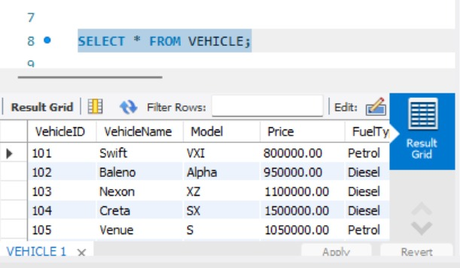
OUT: 2
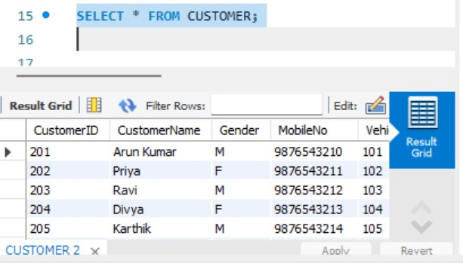
OUT: 3
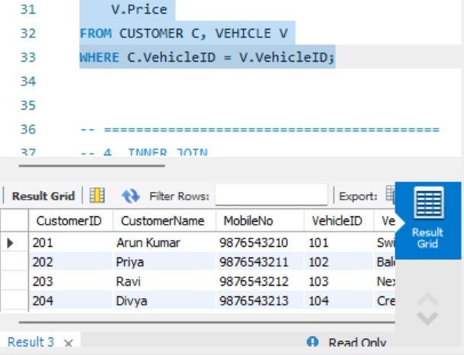
OUT: 4
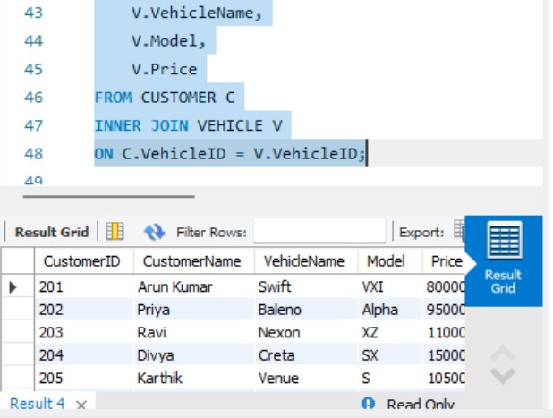
OUT: 5
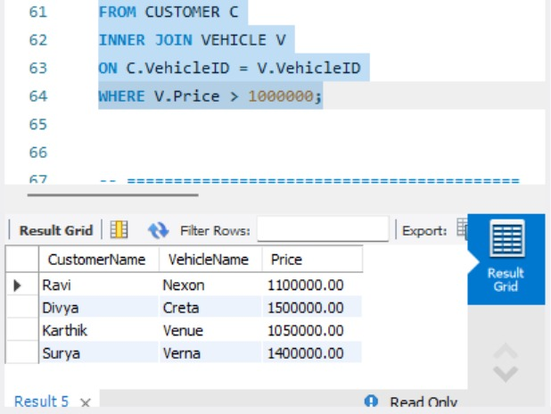
OUT: 6
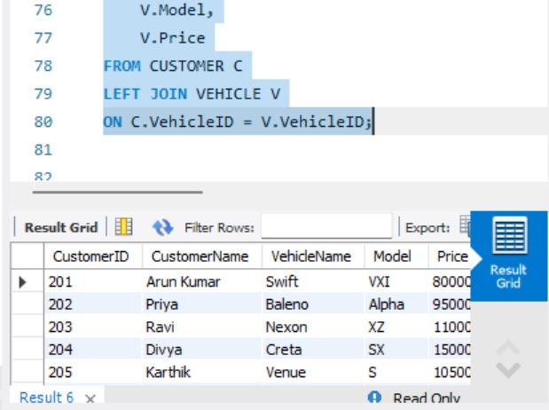
OUT: 7
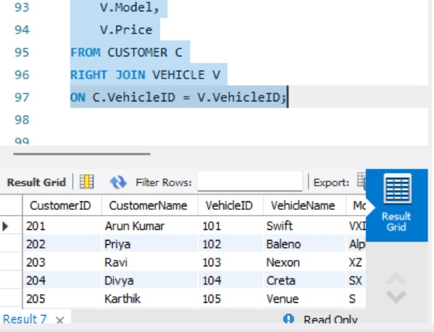
OUT: 8
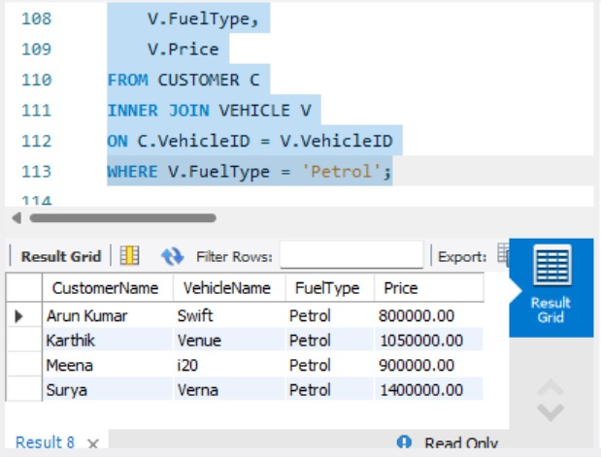
OUT: 9
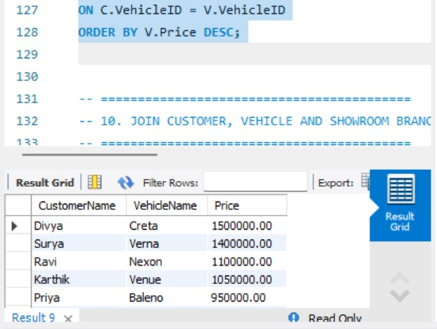
OUT: 10
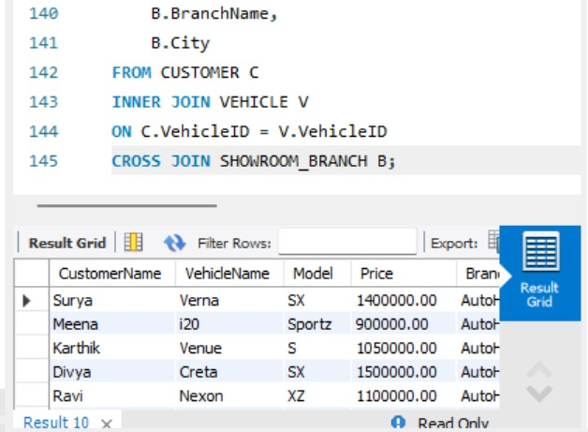
QUERY:
USE AUTOHUB_SHOWROOM;
-- ==========================================
-- 1. DISPLAY VEHICLE TABLE
-- ==========================================
SELECT * FROM VEHICLE;
-- ==========================================
-- 2. DISPLAY CUSTOMER TABLE
-- ==========================================
SELECT * FROM CUSTOMER;
-- ==========================================
-- 3. EQUI JOIN
-- Display customer and vehicle details
-- using VehicleID
-- ==========================================
SELECT
C.CustomerID,
C.CustomerName,
C.MobileNo,
V.VehicleID,
V.VehicleName,
V.Model,
V.Price
FROM CUSTOMER C, VEHICLE V
WHERE C.VehicleID = V.VehicleID;
-- ==========================================
-- 4. INNER JOIN
-- ==========================================
SELECT
C.CustomerID,
C.CustomerName,
V.VehicleName,
V.Model,
V.Price
FROM CUSTOMER C
INNER JOIN VEHICLE V
ON C.VehicleID = V.VehicleID;
-- ==========================================
-- 5. INNER JOIN WITH CONDITION
-- Display customers who purchased
-- vehicles above 1000000
-- ==========================================
SELECT
C.CustomerName,
V.VehicleName,
V.Price
FROM CUSTOMER C
INNER JOIN VEHICLE V
ON C.VehicleID = V.VehicleID
WHERE V.Price > 1000000;
-- ==========================================
-- 6. LEFT OUTER JOIN
-- Display all customers and their vehicles
-- ==========================================
SELECT
C.CustomerID,
C.CustomerName,
V.VehicleName,
V.Model,
V.Price
FROM CUSTOMER C
LEFT JOIN VEHICLE V
ON C.VehicleID = V.VehicleID;
-- ==========================================
-- 7. RIGHT OUTER JOIN
-- Display all vehicles and matching customers
-- ==========================================
SELECT
C.CustomerID,
C.CustomerName,
V.VehicleID,
V.VehicleName,
V.Model,
V.Price
FROM CUSTOMER C
RIGHT JOIN VEHICLE V
ON C.VehicleID = V.VehicleID;
-- ==========================================
-- 8. JOIN CUSTOMER AND VEHICLE
-- Display petrol vehicles purchased by customers
-- ==========================================
SELECT
C.CustomerName,
V.VehicleName,
V.FuelType,
V.Price
FROM CUSTOMER C
INNER JOIN VEHICLE V
ON C.VehicleID = V.VehicleID
WHERE V.FuelType = 'Petrol';
-- ==========================================
-- 9. JOIN WITH ORDER BY
-- Display customer details ordered by price
-- ==========================================
SELECT
C.CustomerName,
V.VehicleName,
V.Price
FROM CUSTOMER C
INNER JOIN VEHICLE V
ON C.VehicleID = V.VehicleID
ORDER BY V.Price DESC;
-- ==========================================
-- 10. JOIN CUSTOMER, VEHICLE AND SHOWROOM BRANCH
-- ==========================================
SELECT
C.CustomerName,
V.VehicleName,
V.Model,
V.Price,
B.BranchName,
B.City
FROM CUSTOMER C
INNER JOIN VEHICLE V
ON C.VehicleID = V.VehicleID
CROSS JOIN SHOWROOM_BRANCH B;
RESULT:
Thus, different types of SQL joins were successfully executed to retrieve related information from multiple tables.

